OSCE Code C.17 DIAGNOSTIC PROCEDURES & TESTS: growth charts

GP TRAINEE INSTRUCTION SHEET

TASK
Look at the child growth charts provided

Student’s tasks
· Analyse the set of growth curves:

· Give general impression of child’s growth (normal or abnormal)

· Describe any variations/deviations in the pattern of growth

· Identify specific point of onset of any significant deviation (When would you start to be concerned? When would you begin work up?)

· Hypothesize on aetiology of variation/deviation in pattern of growth

· Identify additional history needed for complete assessment

· Identify specific physical exam findings to focus on

· Offer a diagnostic approach

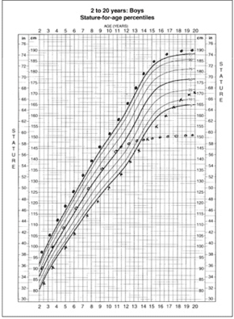
OSCE Code C.17 ASSESSORS INSTRUCTION SHEET

Objective
- Reinforce basic principles of growth in children
- Emphasize the importance of a systematic assessment of growth over time.
- Review the relationship between physical growth and pubertal maturation

The way to analyse growth charts is as laid out in the trainee’s task sheet
· Analyse the set of growth curves:

· Give general impression of child’s growth (normal or abnormal)

· Describe any variations/deviations in the pattern of growth

· Identify specific point of onset of any significant deviation (When would you start to be concerned? When would you begin work up?)

· Hypothesize on aetiology of variation/deviation in pattern of growth

· Identify additional history needed for complete assessment

· Identify specific physical exam findings to focus on

· Offer a diagnostic approach

HANDOUT

Midparental Height Calculations
Midparental height formulas
Boys: [father's height in cm + (mother's height in cm + 13 cm)]/2
Girls: [(father's height in cm – 13 cm) + mother's height in cm]/2
Sample calculations
Midparental height calculations for a son and a daughter of parents with the following heights: father is 172.72 cm, mother is 157.48 cm
Son: [172.72 cm + (157.48 cm + 13 cm)]/2 = 171.6 cm
Daughter: [(172.72 cm – 13 cm) + 157.48 cm]/2 = 158.6 cm

Assessment of Abnormal Growth Curves (Growth Velocity Charts)

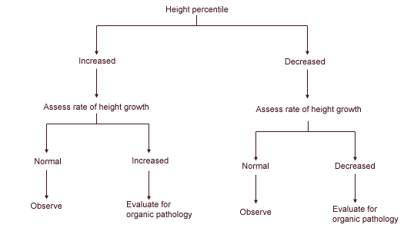

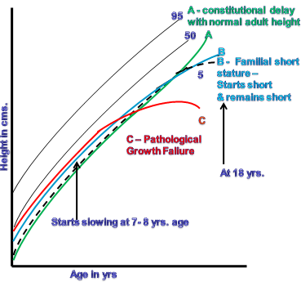

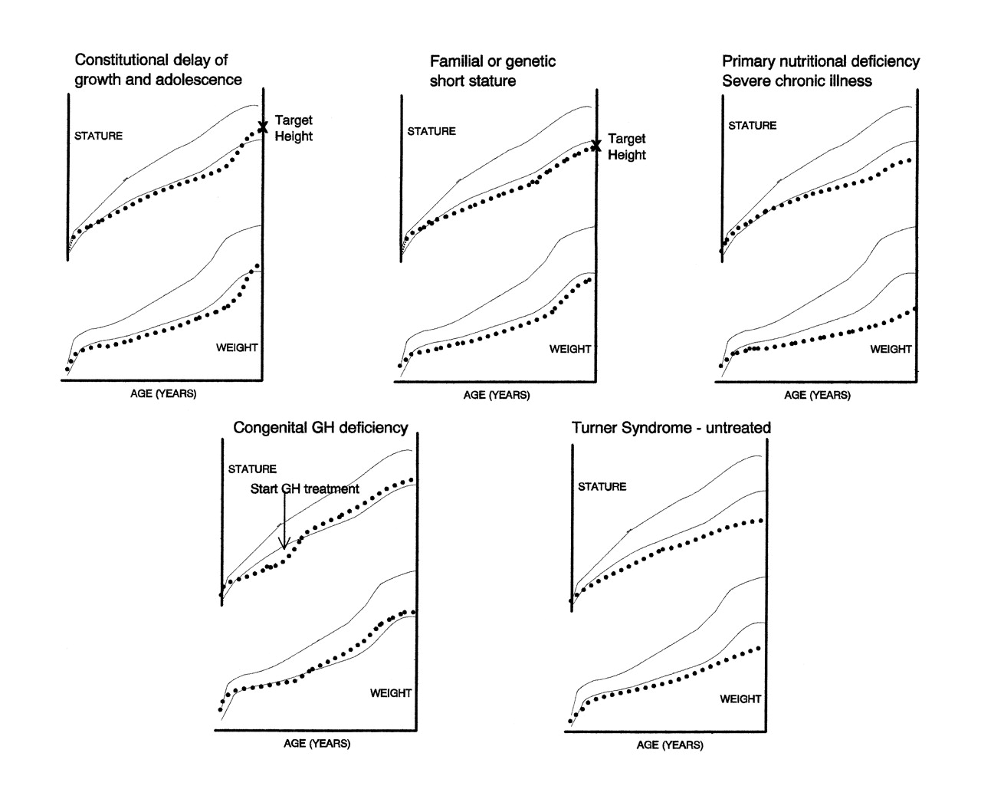

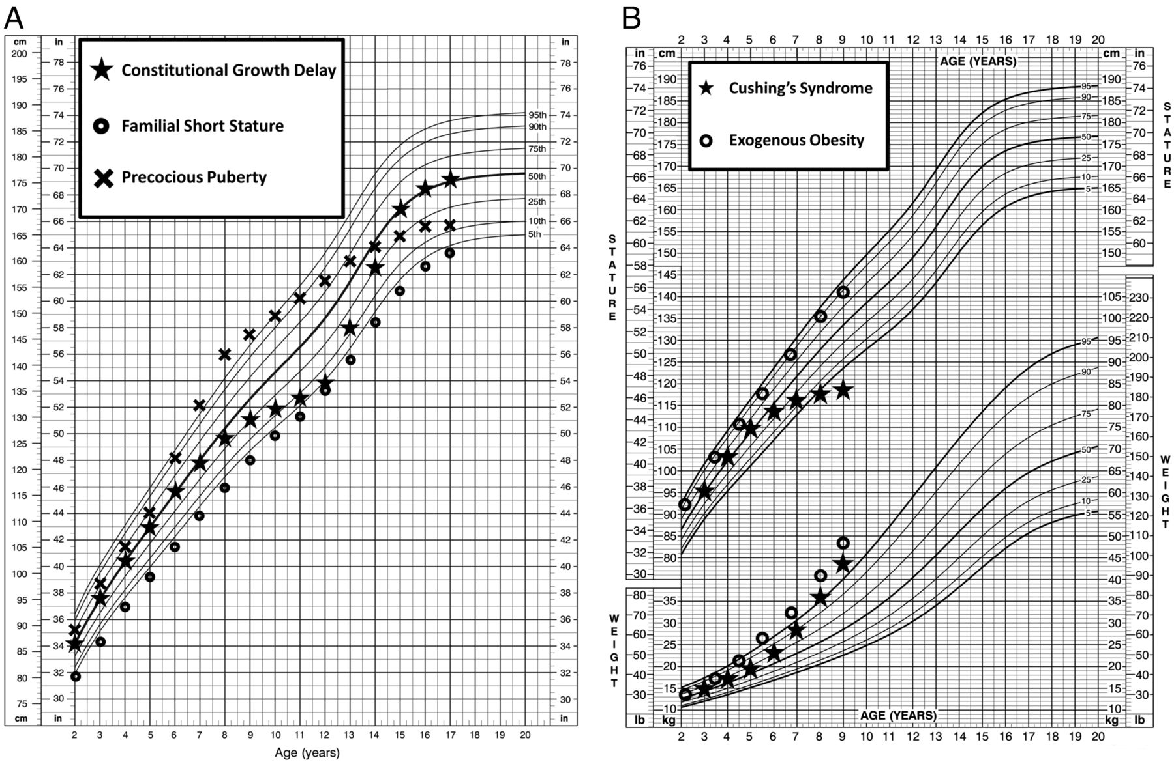

Abnormal Growth Findings Suggesting the Need for Referral
- Height: growth less than the 3rd percentile or greater than the 95th percentile for height
- Growth velocity: decreased or accelerated growth velocity for age (see Table 1 for normal growth velocities)
- Genetic potential: projected height varies from midparental height by more than 5 cm (2 in)
- Multiple syndromic or dysmorphic features: abnormal facies, midline defects, body disproportions
- Bone age: advanced or delayed by more than two standard deviations

Focused Diagnostic Tests in the Evaluation of Abnormal Growth in Children
SUSPECTED CAUSE | DIAGNOSTIC TESTS | ANCILLARY TESTS
Short stature
Celiac disease | Celiac antibody panel: antiendomysial, antigliadin, and tissue transglutaminase antibodies | Endoscopy
Cushing disease | Midnight serum cortisol, salivary cortisol, 24-hour urinary free cortisol estimations | Dexamethasone suppression test
Cystic fibrosis | Sweat chloride test | —
GH deficiency | IGF-I, IGF-binding protein 3 | GH stimulation test
Hypothyroidism | Free thyroxine, TSH | —
Inflammatory disorders | Sedimentation rate, C-reactive protein | Endoscopy
Iron deficiency | Ferritin | Iron, TIBC
Turner syndrome | Karyotype | Echocardiography, renal ultrasonography
Vitamin D deficiency | 25-hydroxyvitamin D, 1,25-dihydroxyvitamin D, parathyroid hormone, ALK-P | Wrist radiography

Tall stature
Beckwith-Wiedemann syndrome |  | Insulin, glucose | Renal ultrasonography
GH excess |  | GH, IGF-I, IGF-binding protein 3 | Pituitary MRI
Homocystinuria |  | Homocysteine, methionine | —
Infant of a mother with diabetes |  | Insulin, glucose | —
Klinefelter syndrome |  | LH, FSH, testosterone | Karyotype
Marfan syndrome |  | Clinical diagnosis using Ghent nosology* | Fibrillin-1 gene mutation, genetic consultation
Precocious puberty
 | Central | LH, FSH, estradiol, testosterone, bone age | GnRH analog stimulation test
 | Peripheral | 17α-hydroxyprogesterone, HCG, DHEAS, estradiol, testosterone, bone age | Cosyntropin (Cortrosyn) stimulation test

